**DAILY ONLINE ACTIVITIES SUMMARY**

|  |  |  |  |  |  |  |  |  |
| --- | --- | --- | --- | --- | --- | --- | --- | --- |
| **Date:** | **08-06-2020** | | | | | **Name:** | **Raksha S** | |
| **Sem & Sec** | **6th B** | | | | | **USN:** | **4AL17CS073** | |
| **Online Test Summary** | | | | | | | | |
| **Subject** | | **CNSC** | | | | | | |
| **Max. Marks** | | **60** | | **Score** | | | **31** | |
| **Certification Course Summary** | | | | | | | | |
| **Course** | **Artificial Intelligence with Python** | | | | | | | |
| **Certificate Provider** | | | **Greatlearning** | | **Duration** | | | **30days** |
| **Coding Challenges** | | | | | | | | |
| Problem Statement: 1. Python program to square odd number from a sequence of list  2. Java program to implement Circular linked list using class and Array. | | | | | | | | |
| **Status:** YES, Completed all Programs | | | | | | | | |
| **Uploaded the report in Github** | | | | | **YES** | | | |
| **If yes Repository name** | | | | | <https://github.com/raksha05/Daily-Status>/Raksha-4AL17CS073/Raksha | | | |
| **Uploaded the report in slack** | | | | | **YES** | | | |

Online Test Details:

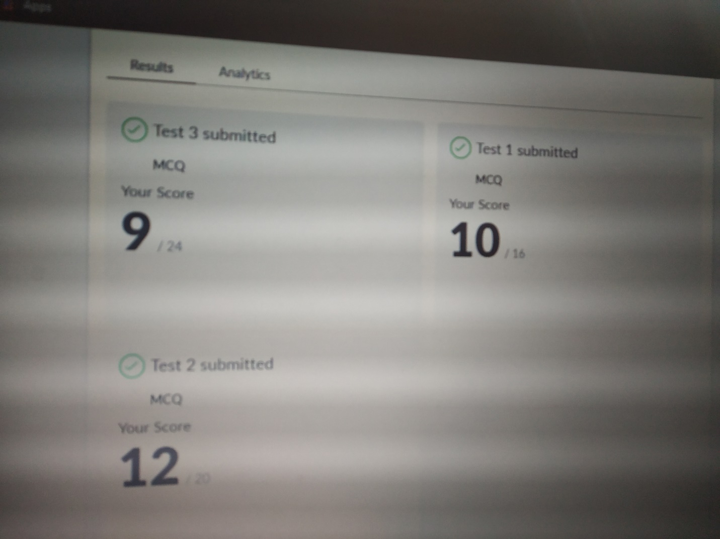

Scored 31 out of 60 in CNSC Test

Certification Course Details:

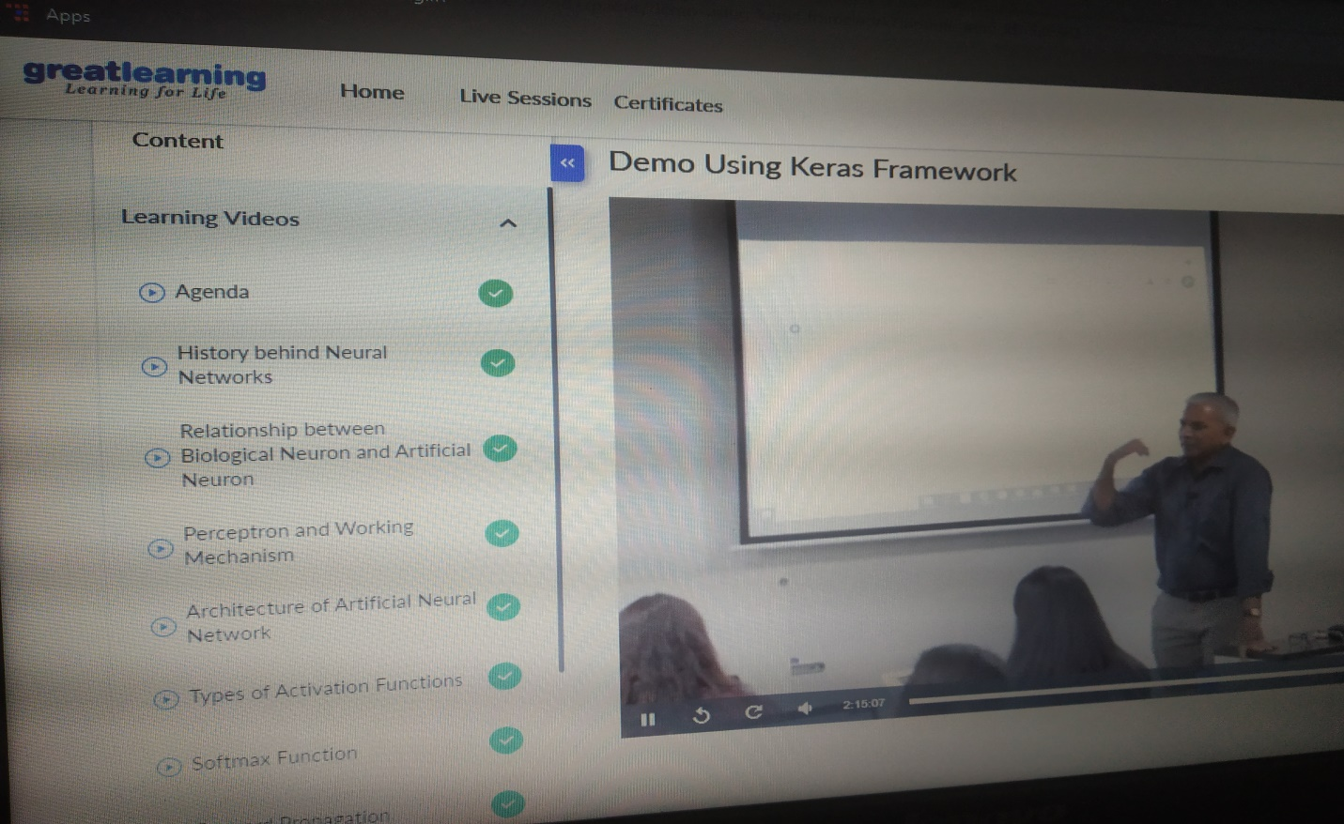

Today in certification based on artificial intelligence with python, I learnt the about architecture of artificial neural network types of functions where it is used and its merits and demerits.If the neurons,layers increases the complexity of errors increases and challenges has to be faced like local maxima and local minima in the model.

Coding Challenges Details:

Program1:

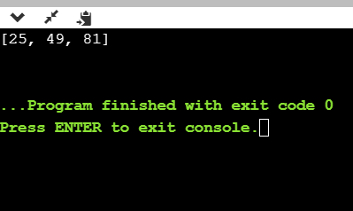

Program2:

